Number book references

The Very Hungry Caterpillar – Eric Carle  (Philomel Books) 1994 – Numbers  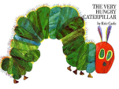 | How big is a million? – Anna Milbourne  (Usborne) 2007 – Large numbers  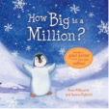
The Very Hungry Caterpillar (English/Urdu) – Eric Carle  (Mantra Lingua) 1992 – Available in a variety of languages | The Great Pet Sale - Mick Inkpen  (Hodder) 2006 – Numbers, money  
10 Little Rubber Ducks Board Book – Eric Carle  (Harper) 2010 – Numbers, positional language development  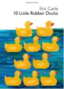 | Ten tiny tadpoles – Debbie Tarbett  (Little Tiger Press) 2006 – Numbers  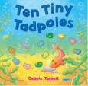

Eight Silly Monkeys – Steve Hascamp  (Intervisual Books) 2003 – Numbers  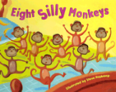 | Ten Terrible Dinosaurs – Paul Stickland  (Ragged Bears Publishing) 2007 – Numbers  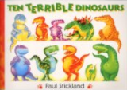
One is a Snail, Ten is a Crab – April Pulley Sayre  (Walker Books Ltd) 2004 – Numbers, calculating  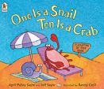 | Don’t forget the bacon – Pat Hutchins  (Red Fox) 2002 – Numbers  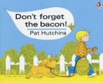
Monster Math – Anna Miranda  (Sandpiper) 2002 – Larger numbers (10, 20, 30)  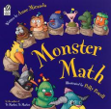 | One Pig Went For a Drive - Alan Durant  (Macmillan Children's Books) 2009 – Numbers  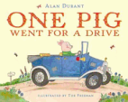

My Granny went to the Market – Stella Blackstone  (Barefoot Books) 2006 – Numbers  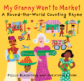 | Ten on a Sled – Kim Norman  (Sterling) 2011 – Numbers  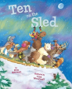
Handa's Hen – Eileen Browne  (Walker Books) 2003 – Numbers  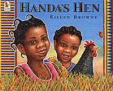 | One Fish, Two Fish, Red Fish, Blue Fish – Dr Seuss (HarperCollins Children's Books) 2003 – Numbers, size, comparing, opposites  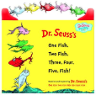
The Doorbell Rang – Pat Hutchins  (Turtleback Books) 1999 – Numbers, sharing  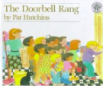 | Rooster's Off to See the World – Eric Carle  (Puffin) 1996 – Numbers, calculating  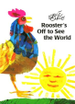

Ten Apples Up on Top! – Dr. Seuss  (HarperCollins Children's Books) 2003 – Counting, calculating  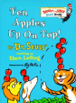 | How Many Snails? – Paul Giganti Jr.  (Greenwillow Books) 1994 – Counting, calculating  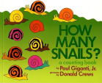
Ten Flashing Fireflies - Philemon Sturges  (North-South Books) 1997 – Counting, calculating  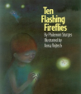 | We All Went on Safari: A Counting Journey Through Tanzania – Laurie Krebs  (Barefoot Books Ltd) 2003 – Numbers, counting  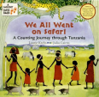
1, 2, 3, to the Zoo – Eric Carle  (Puffin) 1990 – Numbers  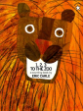 | Dinosaur Dig! – Penny Dale  (Nosy Crow Ltd) 2011 – Numbers, counting  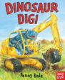

Feast for 10 – Cathryn Falwell  (Houghton Mifflin Juvenile Books) 1995 – Number order, counting  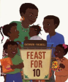 | 10 Button Book – William Accorsi  (Workman Publishing) 1999 – Counting, number order  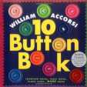
How Do Dinosaurs Count to Ten? – Jane Yolen  (Blue Sky Press) 2007 – Counting, number order  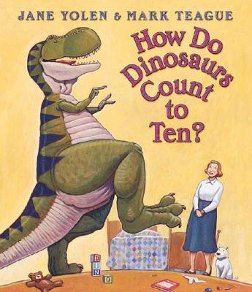 | Anno's Counting Book – Mitsumasa Anno  (HarperCollins Publishers) 1986 – Counting  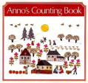
Five Christmas Penguins – Steven Lenton  (Silver Dolphin) 2012 – Counting, number order  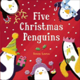 | Ten Black Dots – Donald Crews  (William Morrow) 1996 – Counting, number order  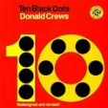

One Hundred Shoes – Tony Ross  (Andersen) 2003 – Large numbers  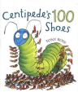 | One Is a Drummer - Thong Lin  (Chronicle Books) 2008 – Numbers, multicultural  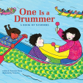
Spot Can Count – Eric Hill  (Puffin) 2013 – Numbers  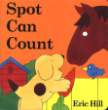 | Curious George's 1 to 10 and Back Again – H. A. Rey  (Houghton Mifflin Harcourt) 2001 – Numbers  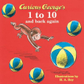
Hanukkah: A Counting Book in English,  Hebrew, and Yiddish – Emily Sper  (Cartwheel Books) 2003 – Numbers, multicultural  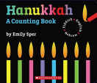 | Easter Babies: A Springtime Counting Book – Joy N. Hulme  (Sterling) 2012 – Number order, counting  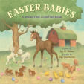

Ten Little Fingers and Ten Little Toes – Mem Fox  (Walker) 2011 – Numbers, counting, calculating  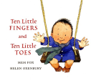 | Baby Touch: Numbers  (Ladybird) 2008 – Numbers  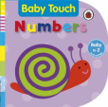
Spot's First Numbers: A touch-and-feel book – Eric Hill  (Warne) 2010 – Numbers  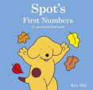 | Ten Little Monkeys Jumping on the Bed  (Child’s Play) 2001 – Numbers, calculating  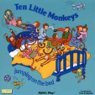
Numbers, Colours, Shapes  (Priddy Books) 2011 – Shape, colour, numbers  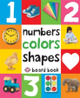 | Five Little Men in a Flying Saucer  (Child’s Play) 2005 – Numbers, calculating  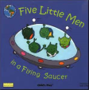

Five Little Ducks  (Child’s Play) 2002 – Numbers, calculating  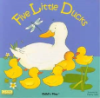 | One Mole Digging A Hole – Julia Donaldson  (Macmillan Children's Books) 2009 – Numbers, calculating  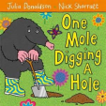
Ten Fat Sausages  (Child’s Play) 2005 – Numbers, calculating  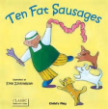 | One Ted Falls out of Bed – Julia Donaldson  (Macmillan Children's Books) 2005 – Numbers, calculating  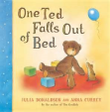
This Old Man  (Child’s Play) 2000 – Numbers, calculating  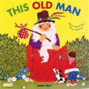 | Five Little Speckled Frogs: BSL  (Child’s Play) 2008 – Numbers, baby sign language  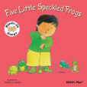

Five Little Ducks: BSL  (Child’s Play) 2008 – Numbers, baby sign language  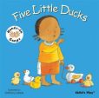 | My First Bilingual Book (Numbers – English/Polish)  (Milet Publishing) 2010 – Numbers  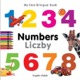
First 100 Numbers  (Priddy Books) 2012 – Numbers  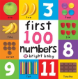 | Ten Little Fingers  (Child’s Play) 2003 – Numbers  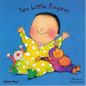
Numbers (Bright Baby Touch and Feel  (Priddy Books) 2008 – Numbers  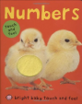 | Baby's Very First Book of 123 – Jenny Tyler  (Usbourne) 2009 – Numbers  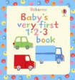

Peter Rabbit 123 – Beatrix Potter  (Warne) 2013 – Numbers  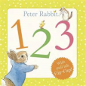 | Bindi Baby Numbers (Hindi) – Aruna K. Hatti and Gnaana  (Gnaana Company) 2011 – Numbers, bilingual  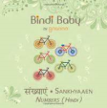
Elmer's First Counting Book – David McKee  (Andersen) 2007 – Numbers  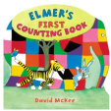 | Ten Tiny Babies – Karen Katz  (Little Simon) 2011 – Numbers  
Number One, Tickle Your Tum – John Prater  (Red Fox) 2002 – Numbers  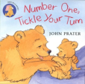 | I Spy Numbers – Jean Marzollo  (Scholastic) 2012 – Numbers  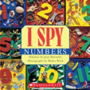

12 Ways to Get to 11 – Eve Merriam  (Aladdin Paperbacks) 1996 – Numbers, calculating  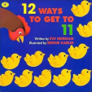 | Baby Touch and Feel Numbers  (Dorling Kindersley) 2013 – Numbers  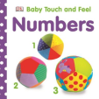
One Monkey Too Many – Jackie French Koller  (Voyager Paperbacks) 2003 – Numbers, calculating  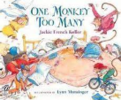 | Numbers – Fiona Land  (Cartwheel books) 2008 – Numbers  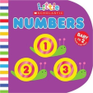
The Numbers of My Jewish Year – Marji E Gold-Vukson  (Kar-Ben Copies Ltd) 2006 – Numbers, multicultural  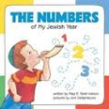 | My Very First Book of Numbers – Eric Carle  (Philomel Books) 2013 – Numbers, bilingual  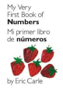

Five Little Froggies (Turkish/English) – Harris Tobias  (Casita Press) 2012 - numbers, bilingual  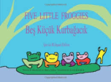 | Kipper's Toybox – Mick Inkpen  (Hodder Children's Books) 2008 – Numbers  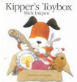
Supermarket Zoo – Caryl Hart  (Simon & Schuster Children’s Books) 2010 – Numbers  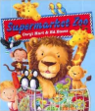 | Room on the Broom – Julia Donaldson  (Macmillan Children's Books) 2002 – Numbers  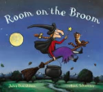
One Bear at Bedtime – Mick Inkpen  (Hodder Children's Books) 1989 – Numbers  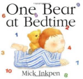 | The Monster Counting Book – Kate Daubney  (Caterpillar Books Ltd) 2011 – Counting, number order  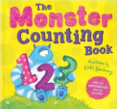

Ten Little Monsters – Sally Hopgood  (Top That! Publishing PLC) 2010 – Counting, number order  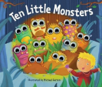 | March of the Dinosaurs – Jakki Wood  (Frances Lincoln Children's Books) 2000 – Counting,  number order  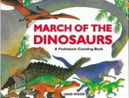
1 2 3: A Child's First Counting Book – Alison Jay  (Dutton Children's Books) 2009 – Number order, counting  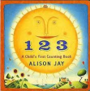 | In My Garden: A Counting Book – Ward Schumaker  (Chronicle Books) 2005 – Numbers, counting  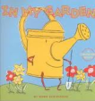
The Icky Bug Counting Board Book – Jerry Pallotta  (Charlesbridge Publishing) 2008 – Number  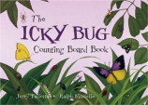 | Ten Little Pirates – Mike Brownlow  (Orchard books) 2013 – Numbers, calculating  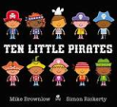
Daddy’s Sandwich - Pip Jones and Laura Hughes  (Faber and Faber) 2015 – Order and sequence  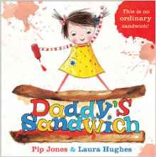 | How many legs? – Kes Gray  (Hodder Children's Books) 2016 – Numbers  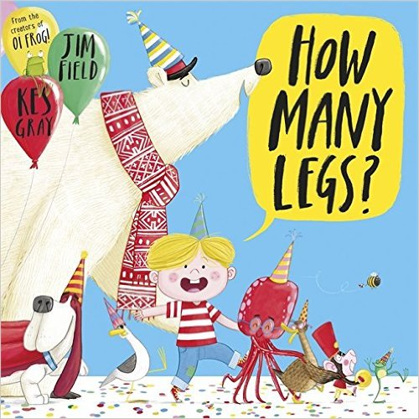
Ten Little Dinosaurs – Mike Brownlow  (Orchard Books) 2015 – Numbers  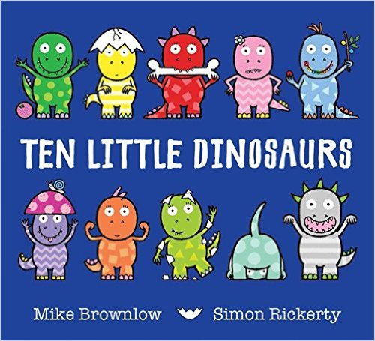  Ten Little Princesses – Mike Brownlow  (Orchard Books) 2014 – Numbers  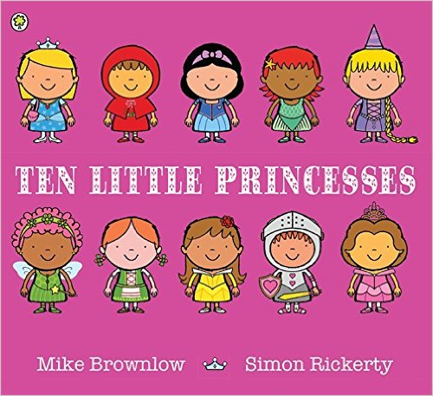 | Ten Little Monsters – Mike Brownlow  (Orchard Books) 2016 – Numbers  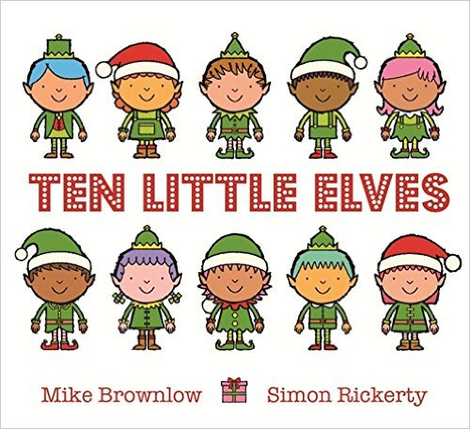  On the Way Home - Jill Murphy  (Macmillan Children's Books) 2007 – Order and sequence  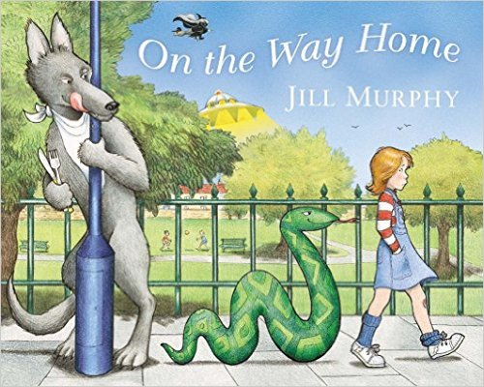
Counting – Julia Donaldson  (Orchard Books) 2016 – Numbers  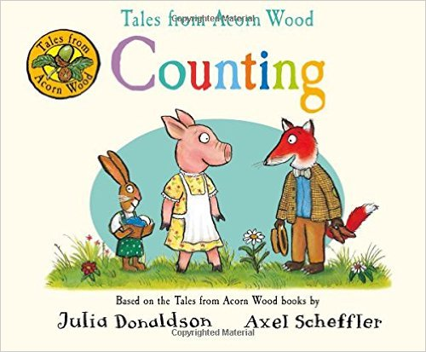 | The Hundred Decker Bus - Mike Smith  (Macmillan Children's Books) 2013 – Large Numbers  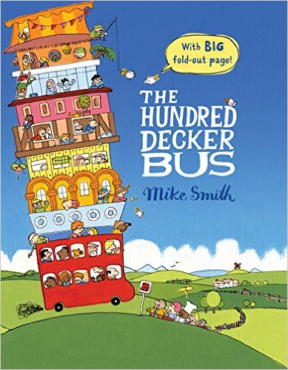
One to Ten and Back Again - Nick Sharratt  (Picture Puffin) 2005 – Counting up and down  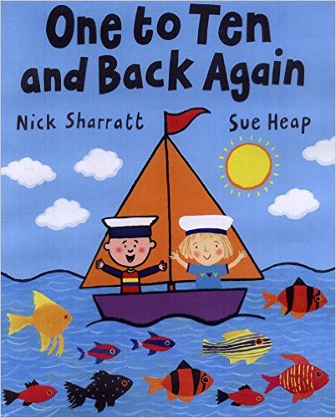 | A Fair Bear Share - Stuart J. Murphy  (HarperCollins) 2016 – One to one correspondence and sharing out  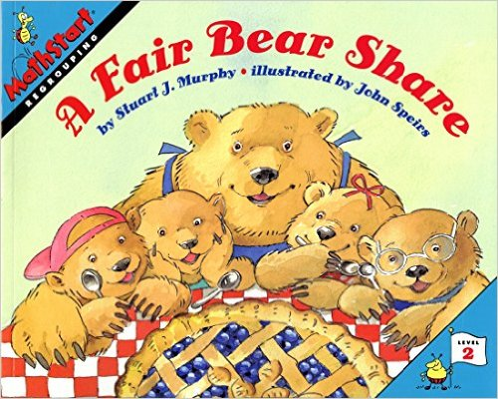

More or Less - Stuart J. Murphy

(HarperCollins) 2016 – More or less, number order and sense

