


Maths Champions
Bringing the Team on the Journey



Contents
1
1. Introduction 3
2. Engaging and motivating the staff team 4
3. Acknowledging hurdles and anxiety 7
4. Checklist of resources to support dissemination of learning from the Maths Champions programme 8
5. Effective strategies to support dissemination and implement learning from the Maths Champions programme 11
6. Summary 17
7. References 18

- Introduction

The Effective Provision of Preschool Education (EPPE) project (2004) identifies a significant link between high-quality preschool provision and better intellectual and social/ behavioral outcomes for children, particularly those from disadvantaged backgrounds. It is widely documented that a motivated and engaged staff team is a key contributing factor to establishing a high-quality early years learning environment.

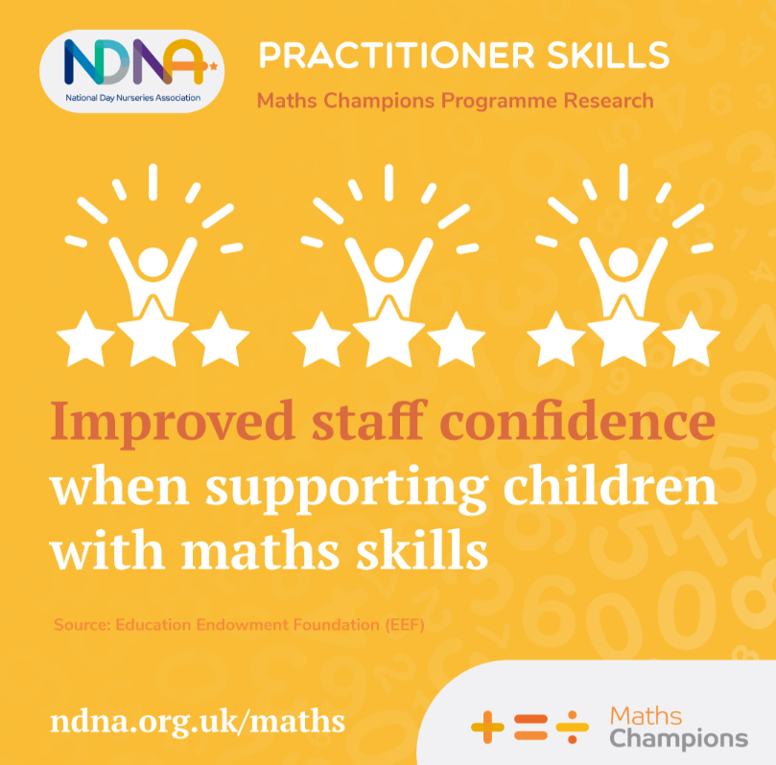
The Maths Champions programme sets the requirement for a nominated Maths Champion to lead the programme, and a Deputy Maths Champion to support implementation. However, all practitioners working with children in your setting will have a role in making the programme a success. Therefore, it is important to include the whole team in the Maths Champions journey and support their mathematical knowledge and confidence, leading to improved outcomes for children.

But, some members of the team may be more excited and willing to get involved than others. One contributing factor to low confidence in supporting maths learning, surrounds practitioners own mathematical confidence, leading to a professional anxiety around the topic.
We know that over a third of adults say that maths makes them feel anxious and one in five are so fearful that it even makes them feel physically sick (KPMG UK and National Numeracy, 2023). Strong evidence also shows that female teachers who are anxious about maths produce maths anxious female pupils (Beilock et al, 2010).
It is essential that we identify and break this cycle wherever we can. Practitioner confidence is important in influencing children to be confident and successful learners, with a positive, resilient attitude towards maths. It also has much wider influences because, as we know, increased confidence leads to increased individual and team wellbeing, and wider workforce retention.
Therefore, to maximise impact, it is important for the Maths Champion and Deputy Maths Champion to recognise their roles as advocates for maths within the setting and consider an inclusive approach to bringing their team on the Maths Champions journey.

- Engaging and motivating the staff team



A motivated team is a productive and effective team. When taking the staff team on any journey of development, it is essential for them to feel involved, empowered, and inspired every day. Teams will naturally feel more engaged and enthusiastic if they have ownership and responsibility for what they are doing – which can be achieved through effective coaching.
Bringing all practitioners on board at the beginning of the journey and using effective coaching skills to disseminate learning from the programme, will positively contribute to the success of the programme, ensuring the maximum impact of children’s mathematical development and practitioner confidence in teaching maths.
The GROW model is one of the most widely used methods for coaching and goal setting in the world today. It was first developed in the United Kingdom in the 1980s by John Whitmore. The GROW model helps individuals and teams to understand their situations and explore their options, while at the same time works to boost their confidence and self-motivation.
The GROW acronym stands for Goals, Reality, Options and Will. By structuring coaching conversations around these four key areas, the GROW model promotes awareness, accountability, engagement, motivation, and improved performance.

The tool on the next page demonstrates how the GROW model can be used alongside the Maths Champions programme. Use these questions during conversations with staff. Opening up these conversations with the team will allow everyone to feel involved and therefore improve feelings of motivation and enthusiasm as they take part in the programme.

How can I engage and motivate the whole staff team to take part in Maths Champions?

Communication   | Effective communication enables team members to build trust. Communicate with your team from the onset and throughout the programme. Create a vision for the programme together (what is it that you want to achieve?) and ensure staff are aware of each step, what their role is and what is happening next. This will help to create a positive working environment where expectations are clear throughout.
Recognition   | Recognition increases staff motivation. Acknowledging and celebrating hard work, achievements, and successes, lets practitioners know they are valued. Recognition can increase staff morale, workforce retention, and improve practice throughout the setting.
Empowerment   | Include the team in discussions about the vision and aims of the programme at each stage. Listen to their opinions and decide as a team how to achieve goals together. Provide practitioners with the tools they need but give them autonomy over tasks which will help them feel empowered.
Training   | Increase staff knowledge and understanding by providing training opportunities for everyone. This will help to boost confidence and keep practitioners motivated to work to the best of their ability, as well as reinforcing the feeling of value in their professional development.

- Acknowledging hurdles and anxiety
Bringing your whole team on the Maths Champions journey will help to raise staff confidence in teaching mathematics, leading to better maths outcomes for children. However, we know that motivating a team and introducing something new can be very difficult for a range of different reasons.
When leading the team through the Maths Champions journey, it is important to acknowledge any hurdles that stand in your way in order to take on a realistic approach.
‘I haven’t had any maths training’
‘I can’t teach maths because I’m no good at maths’

Some of the comments we hear regularly
‘I don’t understand the mathematical terminology’
‘I don’t know how to teach maths’

‘We don’t have enough staff to release individuals for CPD’

‘I don’t have any time to implement this’

Many practitioners lack confidence in teaching maths. They may have:
- An uncertainty about what to teach
- A feeling of being ‘bamboozled’ by mathematical terminology used
- A feeling of being ‘no good’ at maths.
Once acknowledged, these can be supported by effective professional development, ongoing open communication, and support from the Maths Champion and the Deputy Maths Champion through use of the Maths Champions programme resources. There are a range of tools and resources within the programme to help de-mystify mathematical terminology and increase knowledge. There are also resources available to provide practical hands on examples​ of how maths can be supported across the setting.
- Checklist of resources to support dissemination of learning from the Maths Champions programme

The Maths Champions programme has several tools and resources available to disseminate learning to the whole staff team.
Below is a checklist of the key resources available to use, including the aim of the resources and where you can locate them in the programme.

Resource & purpose | Where will I find it in the programme? | Complete
Staff induction pack  Resources to introduce the Maths Champions programme to the whole staff team, providing them with a clear understanding of the programme aims and what to expect | Maths Champions Step 1. Initial Tasks:  - Staff Induction presentation  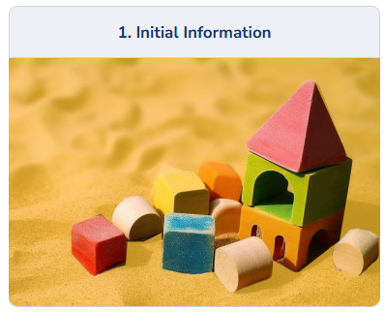  - Staff Induction session plan | ☐  ☐
Reflective Learning Journal  To reflect on and record your Maths Champions journey as a team | Maths Champions Step 2. Reflective Learning Journal:  - Reflective Learning Journal   | ☐
Coaching Course  To support the Maths Champions and Deputy Maths Champion with practical ideas on how to coach staff effectively  Staff Training Pack  Resources to support the whole staff team to develop a sound overall knowledge of early mathematical development  To help de-mystify mathematical terminology and understand mathematical concepts on a deeper level | Maths Champions Step 3. Online Training:  - Training course: Coaching as an Educational Lead  Maths Champions Step 3. Staff Training:  - Key Areas of Mathematical Development presentation and session plan  - Handouts and Staff Knowledge Check   | ☐  ☐  ☐
Children’s Observational Assessment  To support all staff to carry out focused maths observations of children | Maths Champions Step 4. Children’s Observational Assessment:  - Learning Trajectory Ranges  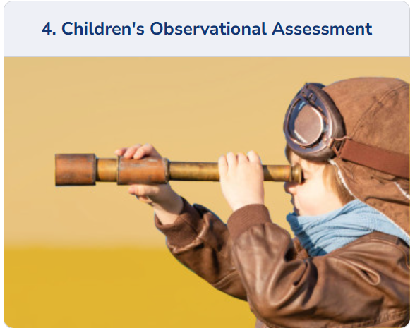  - Children’s Observational Assessment Template | ☐  ☐
Self-Assessment Audits  To support all staff to reflect on their individual knowledge and confidence in supporting early maths | Maths Champions Step 5. Audits:  - Learning Environment Audit Template  - Staff Confidence Audit Template  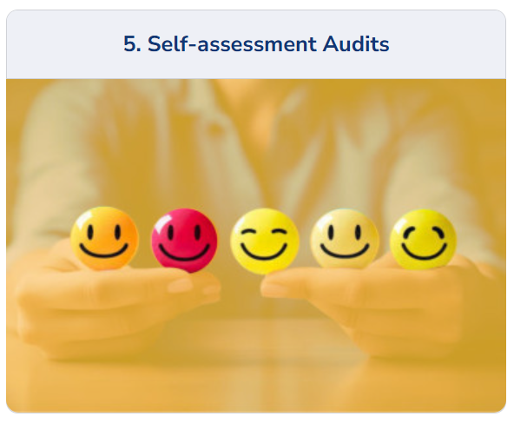 | ☐  ☐
Action Plans  To support all staff to be involved in the development of best practice in early maths | Maths Champions Step 6. Action Plans:  - Learning Environment Action Plan: Template  - Staff Confidence Action Plan: Template   | ☐  ☐
Core Activities  To provide a range of practical ideas to support maths learning that the whole staff team can embed into everyday practice | Maths Champions Step 7. Core Activities:    - Core Activities | ☐
Resources Section  A large resources section which provides printable resources, activity ideas, links to useful articles and websites, and lots more.  It can be used to develop structured CPD opportunities to disseminate learning to the wider staff team and to provide clear explanations and practical examples of what each key concept of maths learning looks in practice | Maths Champions Resources Section  (accessed after Step 7):  Key areas of Mathematical Development folders:  - Bitesize training videos  - Learning trajectories  - Posters  - Top tips  - Focused wider reading  Supporting Staff folder:  - Coaching resources  - Useful links for CPD on pedagogical theory  - Additional training links  Webinars folder:  - Creating Confident Coaches  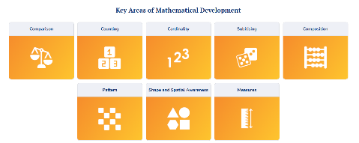 | ☐  ☐  ☐  ☐  ☐  ☐  ☐  ☐  ☐

- Effective strategies to support dissemination and implement learning from the Maths Champions programme

The next section of this guidance explores different ways to disseminate information from the Maths Champions programme to the whole staff team and how to monitor the success of implementation.

In-house training opportunities
In-house training offers a convenient and cost-effective way to develop skills, foster a strong learning culture, and create a consistent, high-quality standard of maths teaching and learning tailored to the specific needs of children attending the setting. What’s more, getting everyone together in this way helps to boost staff confidence, retention and collaboration across the team.
You could use a staff inset day or team meeting/s to share the ‘Key Area of Mathematical Development’ presentation and session plan (See Checklist - Step 3: Staff Training). This will help to introduce and de-mystify mathematical terminology and support practitioners in understanding mathematical concepts on a deeper level.
Alongside the training PowerPoint, there are additional handouts provided which you can share with practitioners, including a handy mathematical terminology reference document (See Checklist - Step 3: Staff Training). There is also a staff knowledge check which can help to identify where staff are with their mathematical knowledge and understanding. You could do this at the beginning and the end of the training session to measure the impact of the session and to identify any areas you may need to follow up on afterwards to further support staff (See Checklist - Step 3: Staff Training).
If you would like to explore a specific key area of mathematical development with your staff team in further detail, you can access bitesize training videos and more in the Resources Section (See Checklist – Maths Champions: Resources Section). These videos and additional resources provide clear explanations and practical examples for practitioners on how each of the key concepts of maths learning can be put effectively into practice.
“Through sharing training and knowledge which I gained as part of this course, I was able to add to the staff team’s knowledge of mathematical development in children.”
Maths Champions PVI setting



One-to-one meetings
One-to-one meetings between a Maths Champion or Deputy Maths Champion and an individual team member can provide individualised support and enhance practice. These meetings allow for open and reflective conversations which are foundational for positive and effective development within the setting and in this case, the overall maths provision.
One-to-one meetings also create a safe space for team members to communicate their thoughts, worries, and needs, which may not be voiced in a larger group meeting. The Maths Champion will gain a deeper understanding of individual interests and needs, meaning they can provide bespoke support and coach more effectively.
Maths Champions (and Deputy Maths Champions) will benefit from accessing and completing the ‘Coaching as an Educational Lead’ training course (See Checklist - Step 3: Online Training). This training course provides practical ideas on how to coach and mentor practitioners effectively within an educational context.
As some Maths Champions and Deputy Maths Champions may be embarking on this as their first experience of coaching, we have also created a webinar, ‘Creating Confident Coaches’. This webinar can be accessed via the Resources Section of the programme in the ‘Webinars’ folder (See Checklist – Maths Champions: Resources Section). This webinar includes top tips and discussion prompts to use when coaching, ideal for your one-to-one meetings.
“Staff would seek how we could help, whether this was helping extend an activity or helping utilise maths conversation opportunities with our staff and children.”
Maths Champions PVI Forest School



Staff meetings
Staff meetings are a great way to improve staff confidence, foster effective communication, collaboration and reflection. These meetings lead to a more unified approach, across all areas of the working environment, including to maths teaching and learning, allowing staff to share thoughts, feelings, expertise, solve problems collectively, and ensure the highest quality maths experiences for all children.
Staff meetings are an ideal opportunity to introduce the Maths Champions programme right from the very start. Maths Champions and Deputy Maths Champions can use the Staff Induction presentation (See Checklist - Step 1: Staff Induction). This will help by introducing the team to the programme, providing them with a clear understanding of the programme aims and what to expect.
Staff meetings will also be an ideal space to share or collaboratively work through different steps of the programme, such as the audits and action plans (See Checklist - Step 5: Audits & Step 6: Action Plans). The audit tools will help the whole staff team to identify where your strengths are and identify any areas for development in relation to your learning environment and staff confidence in supporting and teaching early maths.
As a team, you can consider how to prioritises the areas of improvement identified during the audit process. These will then form the basis of your action plans, to think about focused ways to develop these areas. You will be able to establish the roles each team member will play in achieving your action points and this will help to empower individual team members. You could allocate actions to different rooms or choose individuals to lead on different areas, such as providing more maths opportunities outdoors.
The action plans include a reflection opportunity. Staff meetings will provide you with the perfect time for the team to reflect on and review the effectiveness of what is happening. These reflections will help you to measure the impact the programme has had on the setting, staff and children alike.
Remember to encourage staff to use the reflective journal to record their thoughts and ideas in-between meetings (See Checklist - Step 2: Reflective Journal). This could be whole team reflections, room reflections, or individual staff reflections. Bring this along to meetings to discuss and add notes for next steps to show the story of your Maths Champions journey.
“We decided to create a PowerPoint to share within a staff meeting about what we were learning and how we could use this within everyday play. Staff now feel they understand how to incorporate maths using new and exciting ways.”
Maths Champions PVI setting



Modelling, demonstrating and explaining
Modelling, demonstrating and explaining skills and strategies, especially with regards to early mathematics, gives other team members a structured method to teach and scaffold children's learning. This approach provides a clear visual and auditory demonstration and can be used as a tool for professional development, encouraging practitioners to reflect on their own conduct.
The Maths Champions programme includes core activities (See Checklist - Step 7: Core Activities). The core activities have been designed with clear information, guidance and ideas to help increase staff understanding and confidence in supporting children’s early mathematical learning.
These activities work well when the Maths Champion or Deputy Maths Champion outlines the activity and then models and demonstrates how it looks and works in practice. Maths Champions and Deputy Maths Champions will inspire staff through this method, helping to increase staff’s understanding and confidence in supporting children’s early mathematical learning.
Top Tip: When modelling and demonstrating best practice and mathematical teaching moments, don’t forget to provide team members with explanations about how and why you are doing what you are doing. This is essential to support developing knowledge and confidence.

The Maths Champions programme also includes hundreds of additional tools and resources within the Resources Section which is unlocked which you reach Step 7 of the programme (See Checklist - Maths Champions: Resources Section). You can make use of many additional activity ideas, songs and rhymes, and take inspiration from a wide range of articles, research and much more within this area.

“At first, staff couldn’t see how they could practically fit the activities into the daily routine, but I modelled ideas alongside them and they quickly realised how easy it was, and how there wasn’t really any additional time needed. The activities can be implemented within the daily routine, and can be incorporated into the care routines of individual children’
Maths Champions Maintained Nursery Class

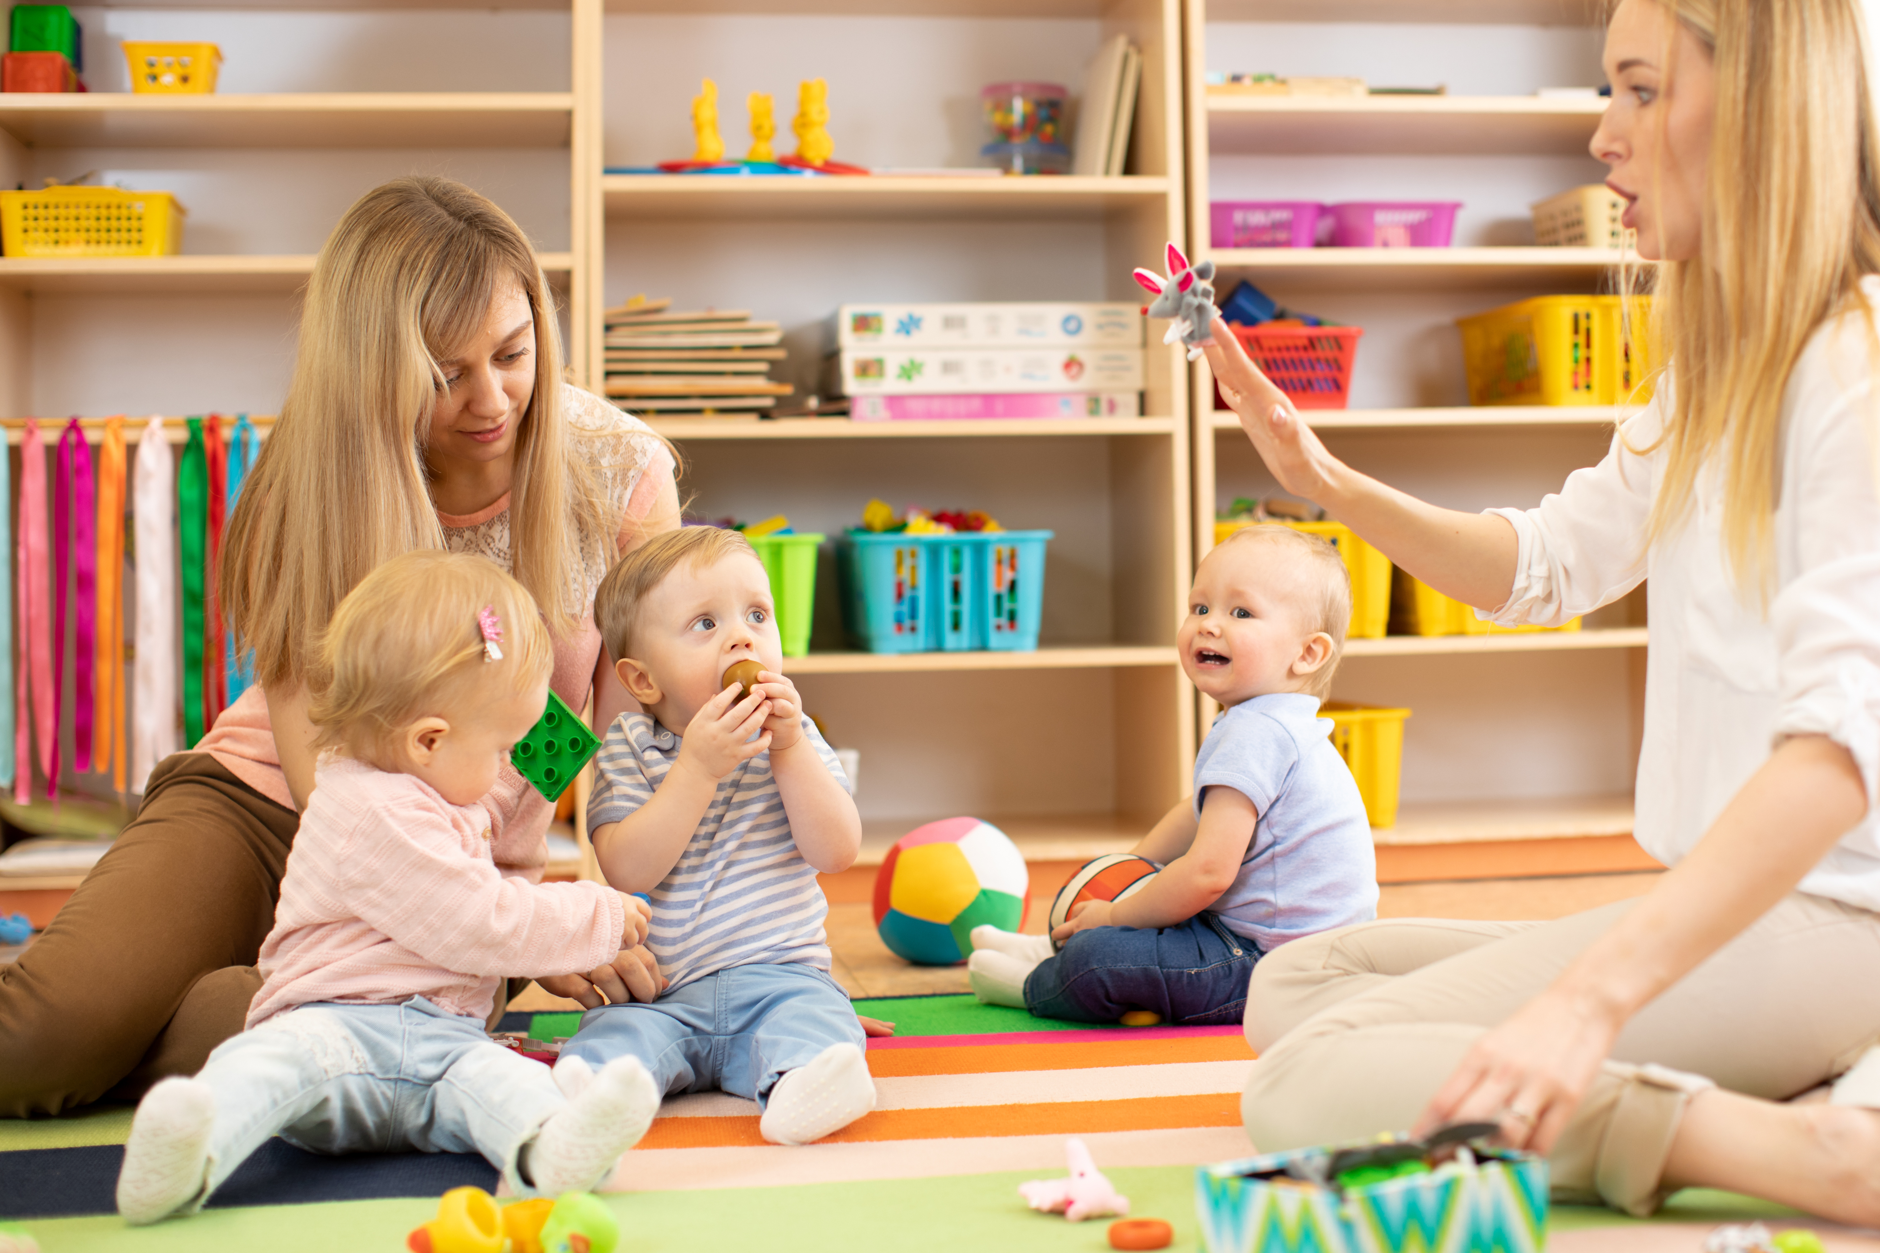

Peer observations
What is peer observation?
Peer observations are planned opportunities for practitioners to observe their colleagues and have a reflective discussion where achievements are celebrated and areas for growth are highlighted. Peer observations can be used to encourage reflective professional growth, raise the quality of provision, and improve outcomes for children. Using peer observation to support the implementation of learning from the Maths Champions programme will help practitioner knowledge and confidence to grow.

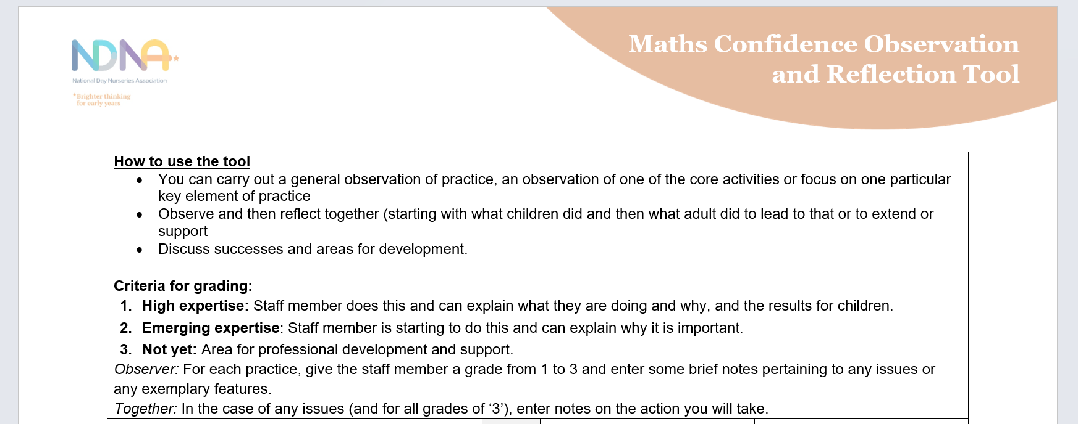
How can I use peer observation to support the dissemination and implementation of learning from the Maths Champions programme?
We have created a ‘Maths Confidence Observation and Reflection Tool’ to support this aspect which you will find in Annex 1 of this document.
This tool can be used to record observations of a chosen key area of mathematical development, meaning you do not need to fill the whole tool during one peer observation. You can use it to build a picture of an individual’s maths confidence as it develops over a number of peer observations.
This tool will help your team to gain a fresh perspective, identify areas for growth in confidence and performance, build trusting and positive relationships between team members and help improve the quality of the maths provision that is provided.

Peer observation top tips

Before the observation
- Establish a positive and supportive culture: Using tools from the Maths Champions programme, such as the training ‘Coaching as an Educational Lead’, identify the most appropriate strategies to effectively support the team

- Agreed focus: Discuss what you would like to observe. For example, is there a particular area of mathematical development that you will be considering?

- Use a peer observation template: Consistent use of the Maths Confidence Observation and Reflection Tool (Annex 1) will provide goal focused, non-judgemental and respectful reflections and feedback.

During the observation
- Keep it brief: Aim to keep your observation to around 10/15 minutes maximum. This will help to maintain focus and prevent tension.

- Be objective: Rather than making assumptions, focus on recording exactly what you see and hear.

After the observation
- Provide constructive feedback: Acknowledge and celebrate what went well first in order to set a positive tone.

- Prioritise: Prioritise one or two areas for development. Feedback should focus more on the positive points with just a couple of areas for development each time.

- Highlight clear, actionable development points: When highlighting areas for development, it is important that they are clear and actionable. This will make things easy to understand and help to maintain motivation towards the overall project.

- Invite dialogue and ideas: When creating development point action plans, encourage the practitioner being observed to come up with their own ideas for development. Use phrases such as ‘What are your thoughts on……?.’ or ‘How do you think you / we could………..?’

- Schedule a follow up: Agree a time and day to come back together to reflect on any action points. This will allow the practitioner to feel valued, giving them the time and opportunity to discuss how suggestions for development have worked in practice.

‘On observing interactions during continuous provision, I have heard more mathematical language being modelled and less closed questioning.’
Maths Champions Maintained School Setting

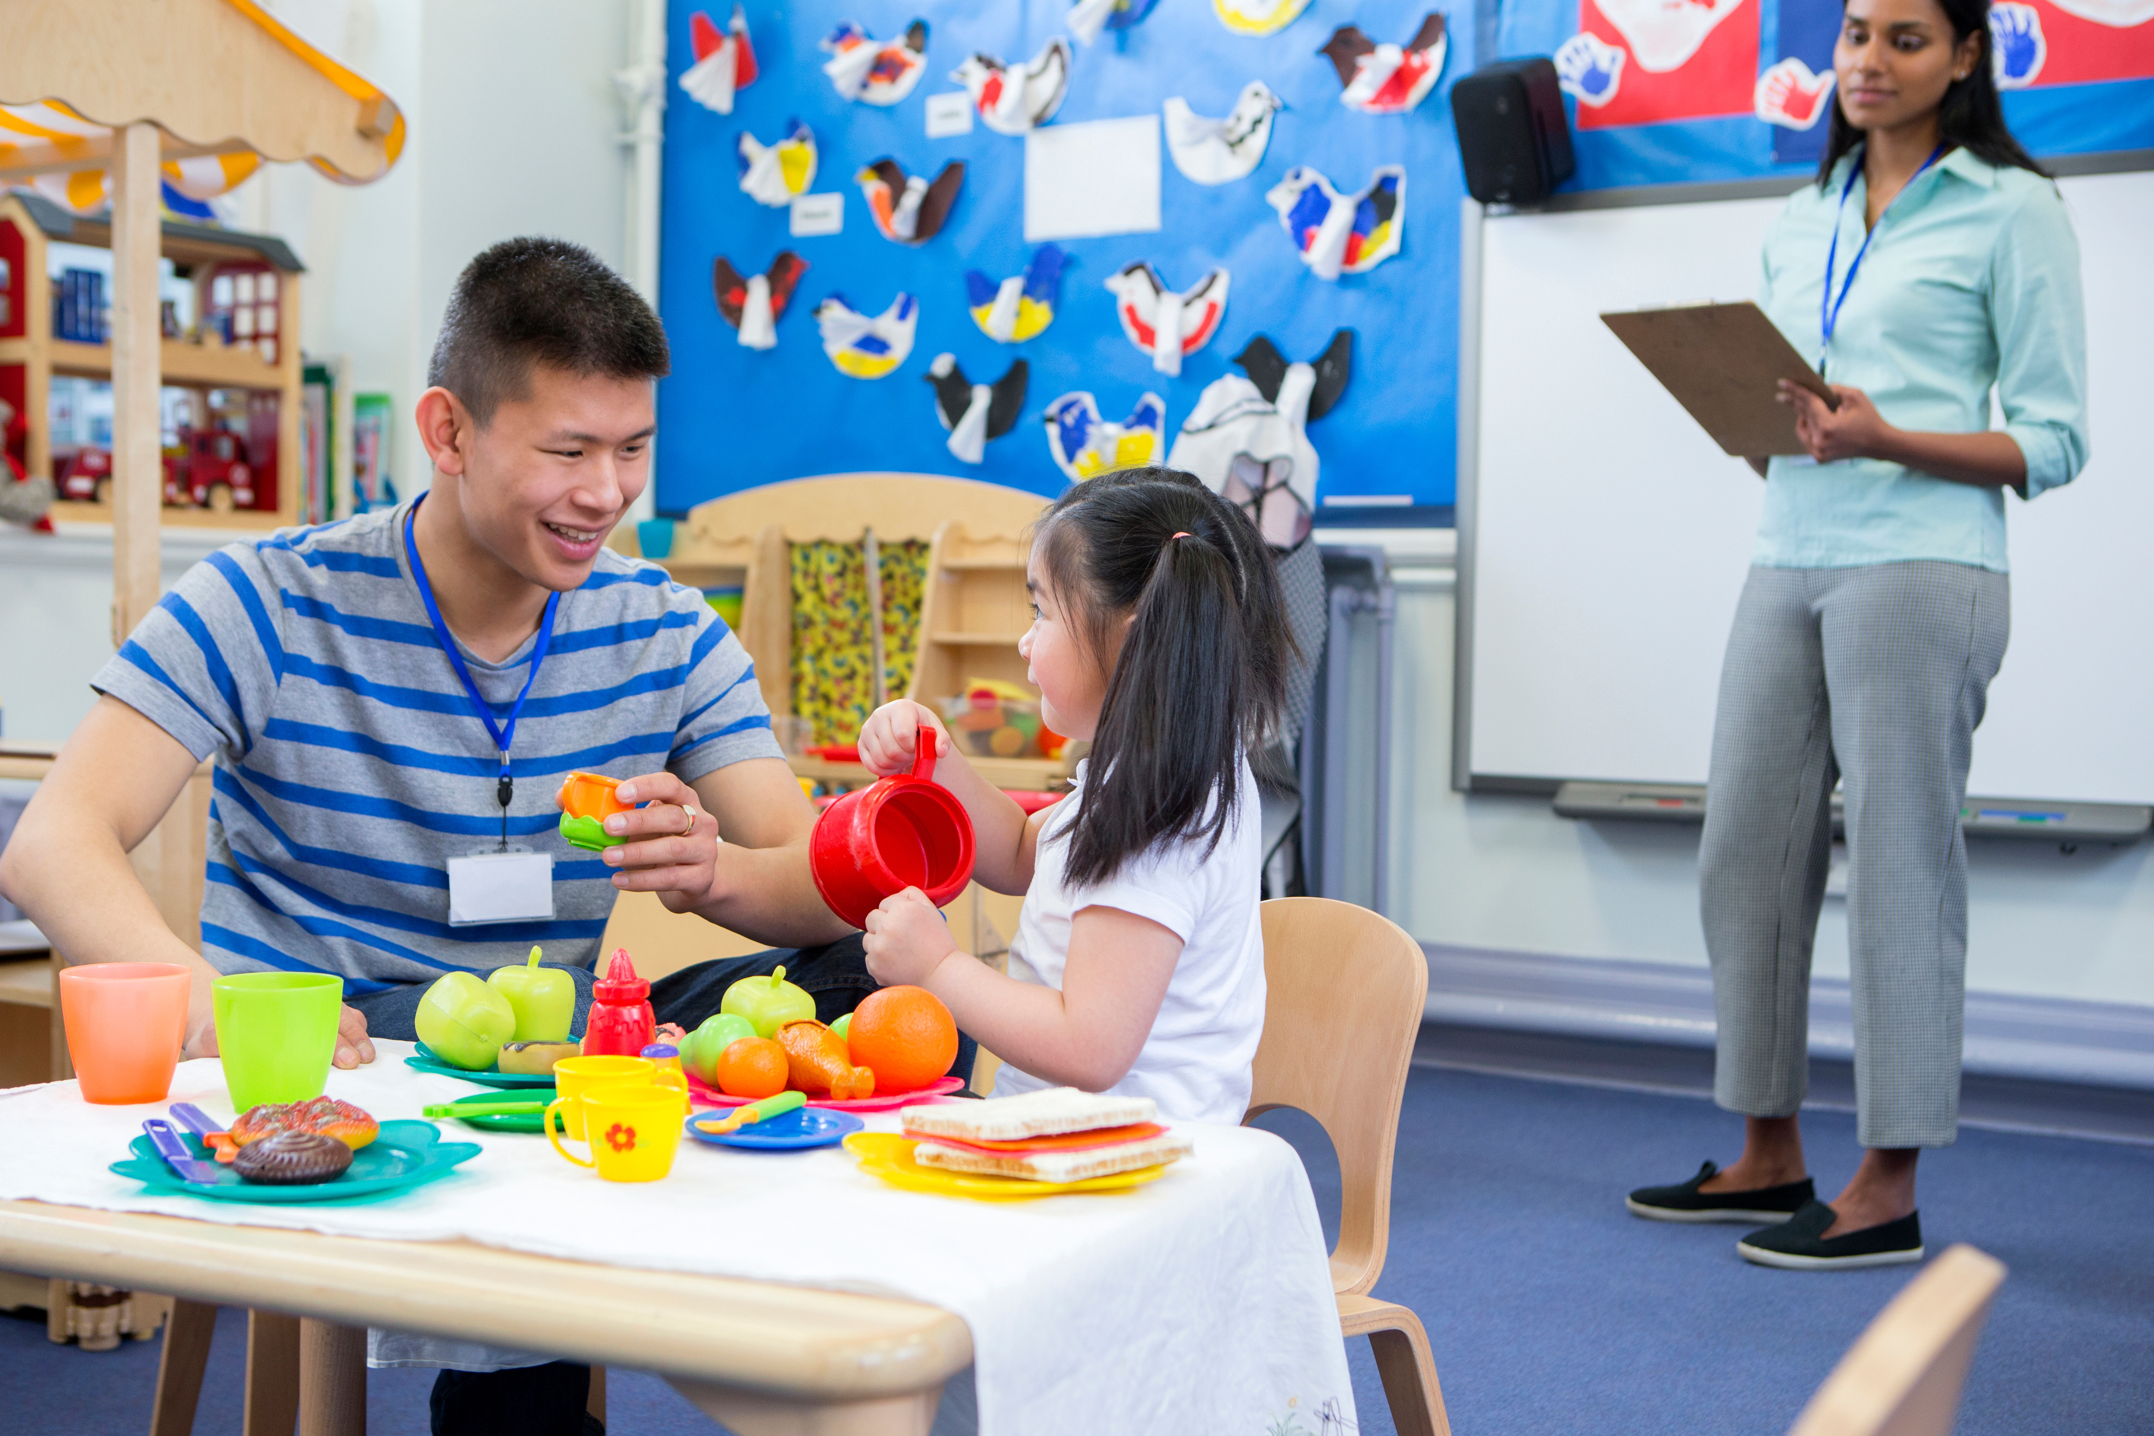

- Summary

Bringing the team on the Maths Champions journey will take time, but the rewards of this will be far reaching for all practitioners and children, now and in the future.
We often get asked how much time settings will need to spend completing the programme. The commitment you make is to complete the 9 steps of the programme. For each setting, the amount of time you spend on these steps will be unique and ultimately decided by you. This will vary depending on your setting’s circumstances, which can include fluctuating factors and ultimately what you want to achieve from the programme.
​Initially, this time will be used by the Maths Champion and Deputy Maths Champion to complete individual CPD in the form of the online training in Step 3 of the programme, and to meet with your Early Years Adviser. But later, this time will be spent coaching, mentoring and modelling best practice to staff, disseminating knowledge and using the core activities to embed maths in practice which can be done whilst working in rooms.
Everything you do throughout your time on programme will impact beyond the 12 months’ access, so the output can far outweigh the input, not only for your own professional development, but for the progression of your setting’s environment, staff knowledge and team confidence, and, most importantly, for the learning outcomes and positive mathematical mindsets of children in your care. ​
Remember, your Early Years Adviser is on hand to support you throughout your time on programme, to answer any questions you may have and to provide feedback and signposting.

- References

Beilock, S.L. et al. (2010) ‘Female teachers’ math anxiety affects girls’ math achievement’, Proceedings of the National Academy of Sciences, 107(5), pp. 1860–1863. doi:10.1073/pnas.0910967107.
KPMG and National Numeracy (2023) Maths anxiety is all too real for ‘sum’. KPMG. Available at: https://kpmg.com/uk/en/media/press-releases/2023/05/maths-anxiety.html (Accessed: 14 November 2025).
Sylva, Kathy; Melhuish, Edward; Sammons, Pam; Siraj-Blatchford, Iram; Taggart, Brenda (2004) The Effective Provision of Pre-School Education (EPPE) Project: Final Report: A Longitudinal Study Funded by the DfES 1997-2004. Institute of Education, University of London/ Department for Education and Skills/Sure Start: London

- Annex 1



Maths Confidence Observation and Reflection Tool
How to use the tool
- You can carry out a general observation of practice, an observation of one of the core activities or focus on one particular key element of practice
- Observe and then reflect together (starting with what children did and then what adult did to lead to that or to extend or support)
- Discuss successes and areas for development.

Criteria for grading:
- High expertise: Staff member does this and can explain what they are doing and why, and the results for children.
- Emerging expertise: Staff member is starting to do this and can explain why it is important.
- Not yet: Area for professional development and support.
Observer: For each practice, give the staff member a grade from 1 to 3 and enter some brief notes pertaining to any issues or any exemplary features.
Together: In the case of any issues (and for all grades of ‘3’), enter notes on the action you will take.
 | Grade | Brief notes | Action plan
Number
Use small and large number words whenever possible: e.g. “There are three dogs” “…. about 100 sharks”, “Millions of pounds ….” Using fingers and linking to numerals where appropriate; counting with children, emphasising cardinal number words, e.g. “There are 1,2,3,4 - four toilets.” Including numbers during routines such as lunchtimes; singing number rhymes and sharing number books.
Engage children playfully in extended number conversations and problem solving, with deliberate mistakes and ludicrous statements: e.g. “I think I can get a thousand conkers in this bucket! I wonder how we can share these?”
Shape and space
Invite children to explore and investigate different shapes of natural and manmade resources, indoors and out: e.g. collections of things with contrasting and interesting shapes, a range of 2D and 3D shapes for making pictures and designs such as loose parts, pattern blocks, building blocks, collage materials.
Use shape language: including the use of formal language (e.g. curved, straight, corners), informal language (e.g. slanty, pointy, twisty, wiggly, bumpy, sticky out bit), common shape names (e.g. cylinder, cone, star, circle, square) and ‘nearly’ shapes (e.g. This is almost a square but it’s got curvy corners). Shape language displayed in meaningful contexts (if wish) including language to describe shape properties such as round, straight, corners, edges, sloping, pointy etc.
Support children to use and understand, positional and directional language in everyday activities including indoor and outdoor play: e.g. obstacle courses, small world play, beebots. Using language such as; up, down, over, under, behind, next to, between, in front of, behind, forwards, backwards. Vocabulary displayed in meaningful contexts.
Observe children’s interests and progress, supporting and posing challenges: e.g. “Could you do a trickier puzzle now?” “Would you like to try to make this model?”
Measures
Use specific and comparative language about length, volume /capacity and weight: e.g. long/short, same length as, taller than, highest, wide/narrow, far, deep; full, empty, overflowing, holds more than, heavier, lighter etc. Vocabulary used (and sometimes displayed) in purposeful contexts: e.g. “Is this bottle full?” “Can you find me a bigger box?” “Can you put the bears in their right beds, which are not too short or too long for them?”
Support children to learn about time through activities, play, routines and resources: e.g. visual timetables, calendars, digital and analogue clocks and watches for reference and exploration; sand and digital timers, stop watches and kitchen timers for timing activities, appointment books in role play, growing things; story books about time, seasons and growing, e.g. ‘The Very Hungry Caterpillar’.
Pose interesting questions for exploration: e.g. “I wonder if this ribbon will be long enough to go round my hat?” “What else would balance the teddy?” “Will this bottle be big enough for all the teddy bears to have cupful at the picnic?” “I wonder if it would be better to fill the bowl with the teaspoon or the ladle?”
General
Support children to develop their mathematical understanding in all areas of experience through:
- Routines e.g. getting dressed, tidying up
- Children’s own interests, e.g. using Peppa Pig or cars to count, using superhero role play to problem solve
- All areas of the setting, indoors and out, e.g. throwing games
- Other areas of learning, e.g. measuring out paints for expressive arts and design, spotting numerals in the environment, map making of the local area, pattern spotting in nature.
Identify opportunities with ICT: in a variety of formats and tools, e.g. beebots, calculators, PC, tablet, whiteboard games, cameras, printers.
Support children with English as an additional language: to develop their mathematical language and understanding, drawing on information from families about home experiences, e.g. finger counting, rhymes and journeys.
Identify and use Characteristics of effective teaching and learning in both child-led and adult-led activities: e.g. playing with what they know, thinking of ideas, finding ways to solve problems, making predictions.
Observe and support children’s interests and progress: commentating and posing challenges, e.g. “I love the way you arranged those to count them; I bet you can’t fit 10 in there!” “I wonder if you could do an even trickier puzzle?” “Would you like to try to make this model with me?”
Share children’s mathematical learning with parents: including gaining information about family experiences and using varied resources to support parents with home learning opportunities in maths, e.g. sharing number rhymes and games ideas.

