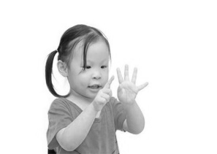
A Parents’ Guide to the Math Champion Programme
Edit here{Setting name/Room name}

Our setting is currently completing the Maths Champions programme. This guidance will provide information about the programme and the benefits for our setting and for your child.

What is Maths Champions?
Maths Champions is an exciting online training programme that will give staff a deeper understanding of how young children learn maths and how we can ensure children develop lots of important maths skills.

What does the programme involve?
Staff training: As part of the programme, staff will complete training to gain more knowledge of the maths skills that young children develop
Audits: We will carry out audits to help us look at what opportunities and experiences we currently offer to develop children’s maths skills and what new things we could do to improve
Observations: We will observe children to make sure that all of the new experiences we provide are helping to develop new maths skills
Core activities and resources: We will carry out regular activities and use different resources which will help us provide lots of opportunities for children to use different maths skills during their play.

Why is maths so important for my child?
Research shows that children’s mathematical learning in the early years makes a difference to the whole of their lives.
“Early maths helps children make sense of the world, interpret situations, and solve problems.
Early maths skills are strongly linked to a child’s mathematical achievement in primary and secondary school.”
Education Endowment Foundation

How will the programme impact my child?
We hope you will most likely notice your child using more problem solving, maths skills and maths language in their play. Things such as:
- Counting and using number
- Grouping and comparing objects according to size or shape
- Comparing the weight or size of different objects
- Exploring shape
- Creating patterns.

How can I get more information about maths and how can I support my child’s maths learning at home?
For more information on maths please ask a member of staff.
At home, here are a few ideas of how you can support your children’s maths skills:
- Sing number rhymes
- Involve children in routines such as setting places at the table or shopping for amounts of things
- Collect natural objects such as leaves and twigs to make different patterns
- Play ‘shops’
- Play games such as snakes and ladders, jigsaws or hopscotch
- Talk with your child about numbers, amount, size, shapes and patterns every day.

