Professional development references

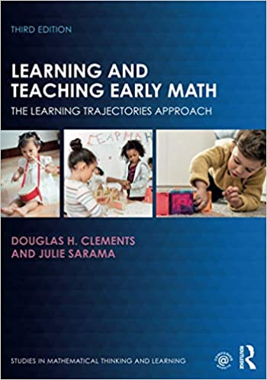

***Learning and teaching early math: the learning trajectories approach.***

Clements, D.H & Sarama, J.

2020

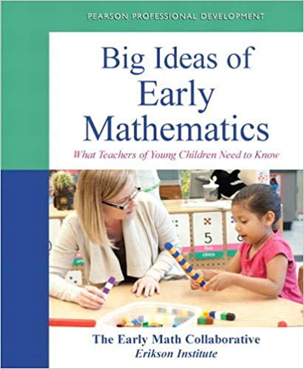

***Big ideas of early mathematics***

Early Math Collaborative Erikson Institute

2013

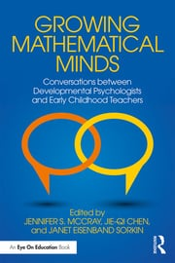

***Growing mathematical minds.***

McCray, J.S., Chen, J- Q. & Sorkin, J.E.

2019

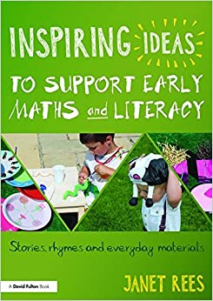

***Inspiring Ideas to Support Early Maths and Literacy: Stories, rhymes and everyday materials***

Rees, J

2016

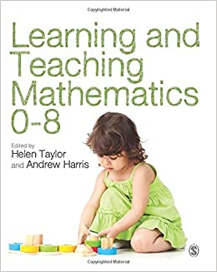

***Learning and Teaching Mathematics 0-8***

Taylor, T and Harris, A

2013

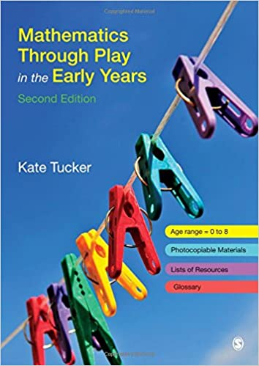

***Mathematics through Play in the Early Years, Sage***

Tucker, K

2014

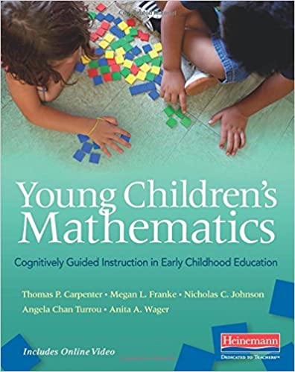

***Young children's mathematics***

Carpenter, Franke et al

2016