Shape, space and measure book references

The Bad-Tempered Ladybird – Eric Carle  (Puffin) 2010 – Size, time   | Cluck O'Clock – Kes Gray  (Hodder) 2010 – Time  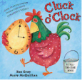
Maisy’s First Clock – Lucy Cousins  (Candlewick Press) 2011 – Time  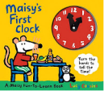 | What's the Time, Mr Wolf? – Debi Gliori  (Bloomsbury) 2013 – Time  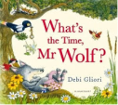
Tom and the Tinful of Trouble – Nick Sharratt  (Scholastic) 2007 – Time  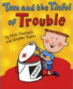 | Count Down to Bedtime – Mike Haines  (Hyperion Books) 2001 – Time, numbers  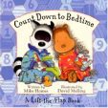

Mr Wolf's Nursery Time – Colin Hawkins, Jacqui Hawkins  (Egmont Books) 2005 – Time  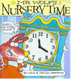 | Time for Bed – Petr Horacek  (Walker) 2013 – Time sequence and routine  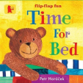
Benji Bear's Busy Day – Tor Freeman  (Campbell Books) 2013 – Time  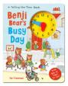 | Baby Says Peekaboo! – Dorling Kindersley  (Penguin Books) 2013 – Positional language  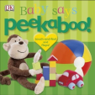
Bunny Day: Telling Time from Breakfast to Bedtime –  Rick Walton  (Harper Collins) 2002 – Time  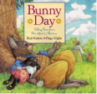 | We're Going on a Bear Hunt – Michael Rosen  (Walker Books Ltd) 1997 – Positional language  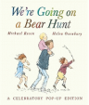

Where Is Maisy? – Lucy Cousins  (Candlewick Press) 2010 – Positional language  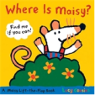 | We're Going on a Lion Hunt – David Axtell  (Macmillan Children's Books) 2000 – Positional language  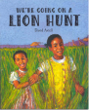
Wind the Bobbin Up – BSL (Hands-On Songs)  (Child’s Play) 2008 – Directional language, baby sign language  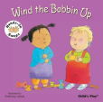 | Mr Archimedes' Bath – Pamela Allen  (Puffin) 1994 – Capacity, measure and estimation  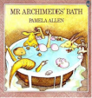
Incey Wincey Spider – BSL (Hands-On Songs)  (Child’s Play) 2008 – Directional language, baby sign language  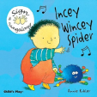 | Mighty Maddie – Stuart J Murphy  (Harper Collins) 2004 – Weight  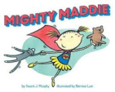

Who Sank the Boat? – Pamela Allen  (Puffin) 1998 – Weight  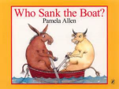 | Tall – Jez Alborough  (Walker Books Ltd) 2004 – Size  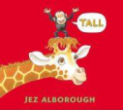
Super Sand Castle Saturday – Julia Gorton  (William Morrow) 1999 – Positional language and size  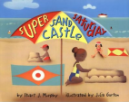 | Mouse is Small – Mary Murphy  (Walker) 2013 – Size  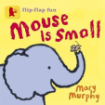
Where’s My Teddy – Jez Alborough  (Walker Books Ltd) 2004 – Size   | The Smartest Giant in Town – Julia Donaldson & Axel Scheffler  (Macmillan Children's Books) 2003 – Size  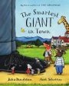

Maisy Big, Maisy Small – Lucy Cousins  (Walker) 2012 – Size, comparison, opposites  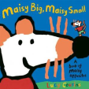 | Dear Zoo – Rod Campbell  (Macmillan Children's Books) 2010 - Shapes, size and spatial awareness  
Titch – Pat Hutchins  (Red Fox) 1997 – Size   | Three Billy Goats Gruff – Alison Edgson  (Child's Edition) 2007 – Size, positional language  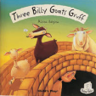
The Snail and the Whale – Julia Donaldson  (Macmillan Children's Books) 2004 – Size  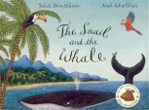 | Pardon said the giraffe – Colin West  (Walker) 2009 – Size and comparison  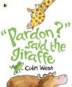

My Daddy is a Giant in Polish and English – Carl Norac  (Mantra Lingua; New Ed) 2005 – Size and bilingual   | The Little Mouse, the Red Ripe Strawberry, and the Big Hungry Bear – Audrey and Don Wood  (Child’s Play) 1987 – Size, fractions  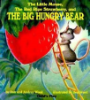
Goldilocks and The Three Bears - Heather Amery  (Usborne Publishing Ltd) 2003 - Size and comparison  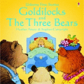 | Just a Little Bit – Ann Tompert  (Houghton Mifflin) 1996 – Size, measure, weight and comparison  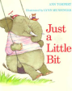
Goldilocks & The Three Bears – Kate Clynes  (Mantra Lingua) 2003 - Size and comparison and bilingual   | Room on the Broom - Julia Donaldson  (Macmillan Children's Books) 2002 – Size, direction  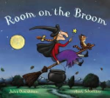

Aliens Love Underpants! – Claire Freedman  (Simon & Schuster Children's) 2007 – Size and patterns   | Rosie's Walk – Pat Hutchins  (Red Fox) 2003 – Distance and numbers  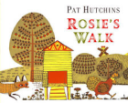
I Am Small – Emma Dodd  (Cartwheel Books) 2011 – Size, speed, measure, comparison  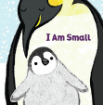 | Measuring Penny – Loreen Leedy  (Square Fish) 2000 – Length  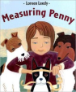
Slowly, Slowly, Slowly, Said the Sloth – Eric Carle  (Puffin) 2005 – Speed  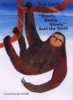 | The Greedy Triangle – Marilyn Burns  (Scholastic) 2008 – Shapes  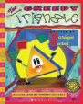

Bear in a Square – Stella Blackstone  (Barefoot Books) 2007 – Shapes  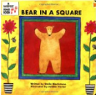 | Elmer’s friends – David McKee  (Andersen) 1994 – Patterns, size, shapes  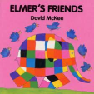
Circus Shapes – Stuart J Murphy  (HarperCollins) 1998 – Shapes  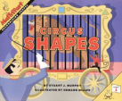 | Elmer's Colours – David McKee  (English-Polish) (Milet) 2010) – Colours, bilingual  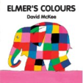
Dinosaur Shapes – Paul Stickland, Henrietta Stickland  (Ragged Bears Publishing) 2005 – Shapes and numbers  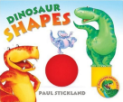 | My First Bilingual Book – Opposites: English-Polish  Milet) 2012 – Opposites and bilingual  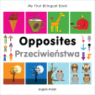

Curious George Shapes – Margret Rey  (Houghton Mifflin Harcourt) 2008 – Shapes  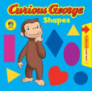 | Baby Touch: Shapes  (Ladybird) 2008 – Shapes  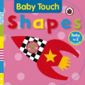
Spot's First Shapes – Eric Hill  (Warne) 2011 – Shapes  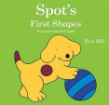 | Baby Touch: Big Noisy Playbook – Justine Swain-Smith (Ladybird) 2011 – Shapes  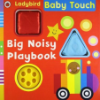
Numbers, Colours, Shapes – Roger Priddy  (Priddy Books) 2011 – Shapes, colours and numbers  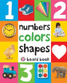 | Colours and Shapes (Baby Touch and Feel)  (Dorling Kindersley) 2009 – Colours and shapes  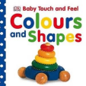

Baby Shapes 1-2-3 – Helen Dorman  (CP Publishing) 2013 – Shapes  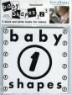 | Monster Knows Shapes – Lori Capote  (Picture Window Books) 2013 – Shapes  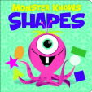
Shapes (Bright Baby Touch and Feel) – Roger Priddy  (Priddy Books) 2008 – Shapes  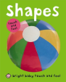 | The shapes of my Jewish Year – Marji E Gold-Vukson  (Kar-Ben Copies Ltd) 2003 – Shapes, multicultural  
I See Shapes (Baby Einstein) – Susan Ring  (Disney Press) 2010 – Shapes  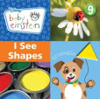 | Shapes – Little Scholastic  (Cartwheel books) 2008 – Shapes  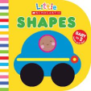

My Very First Book of Shapes – Eric Carle  (Puffin) 2005 – Shapes  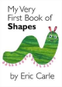 | Norman, the slug with the silly shell – Sue Hendra  (Simon and Schuster) 2005 – Patterns
10 Color Book – William Accorsi  (Workman Publishing) 2008 – Shapes and colours  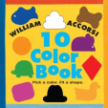 | You can’t take an elephant on the bus – Patricia Cleveland-Peck  (Bloomsbury Children) 2015 – Size and problem solving  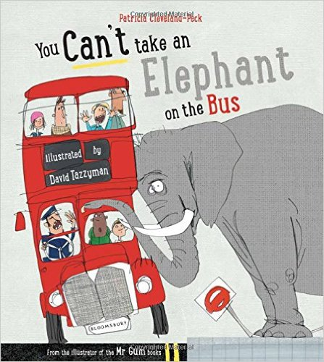
Fox’s socks – Julia Donaldson  (Macmillan Children's Books) 2015 – Positional and directional  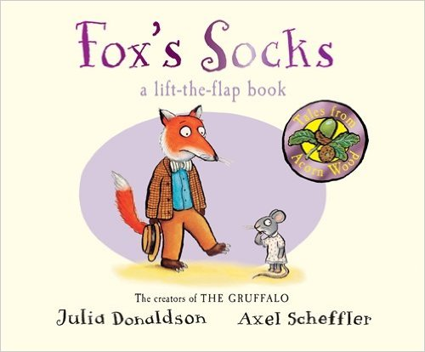 | Faster, Faster, Nice and Slow – Nick Sharratt  (Puffin) 2006 – Speed  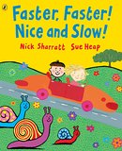
Socks – Nick Sharratt  (Puffin) 2016 – Patterns  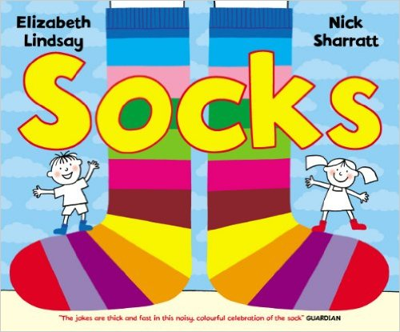 | Captain Invincible and the Space Shapes - Stuart J. Murphy  (HarperCollins) 2016 – Shapes  