Professional development references

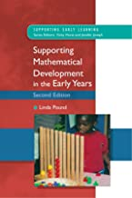

***Supporting Mathematical Development in the Early Years***

***Second Edition***

Pound. L

2006

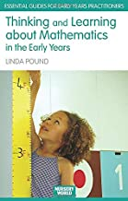

***Thinking and Learning about Mathematics in the Early Years***

Pound. L

2008

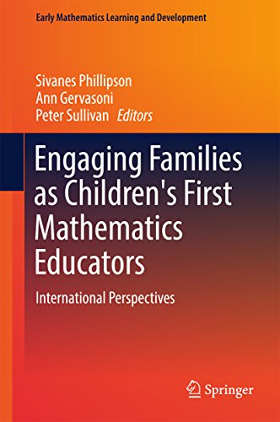

***Engaging Families as Children's First Mathematics Educators: International Perspectives (Early Mathematics Learning and Development)***

Phillipson. S, Gervasoni. A, Sullivan. P

First Edition

2017

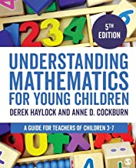

***Understanding Mathematics for Young Children: A guide for teachers of children 3-7 years.***

Fifth Edition

Haylock. D & Cockburn. A

2017

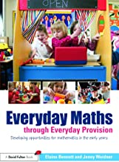

***Everyday Maths through Everyday Provision***

Bennett. E & Weidner. J

2011

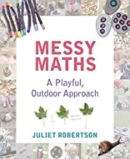

***Messy Maths: A Playful, Outdoor Approach***

Robertson. J

2017

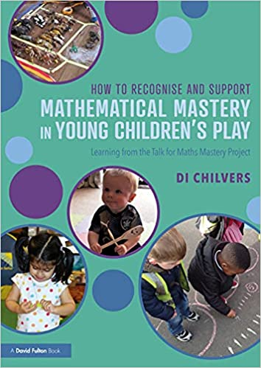

***Mathematical Mastery in Young Children’s Play***

Chilvers. D

2021

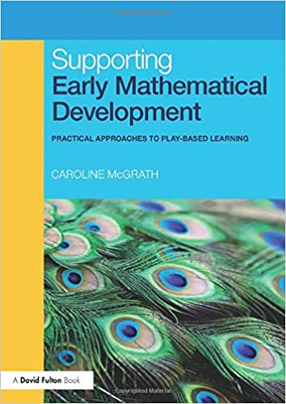

***Early Mathematical Development:***

***Practical Approaches to Play-Based Learning.***

McGrath. C

2010

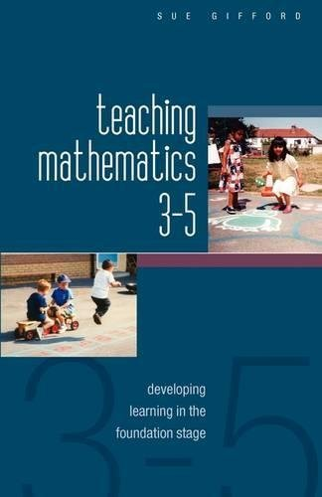

***Teaching Mathematics 3-5: Developing Learning In The***

***Foundation Stage***

Gifford. S

2005

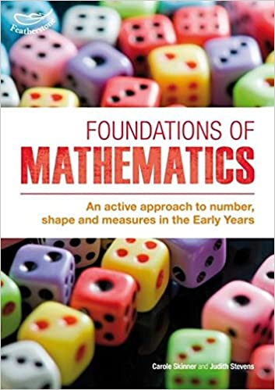

***Foundations of Mathematics: An Active Approach to Number, Shape and Measures in the Early Years***

Skinner. C

2013

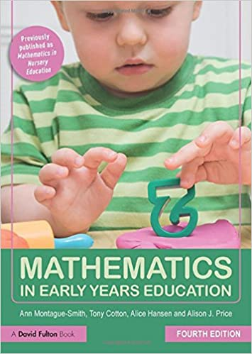

**Mathematics in Early Years**

Montague-Smith. A, Cotton. T, Hansen. A, Price, A

2017

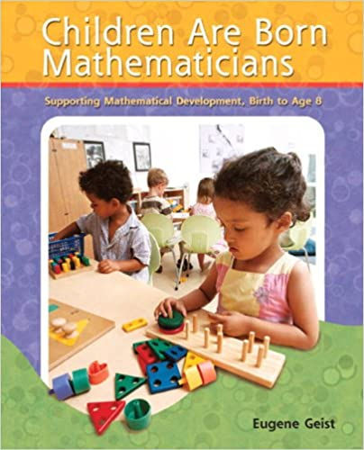

***Children are Born Mathematicians:***

***Supporting Mathematical Development, Birth to Age 8***

Geist. E

2008

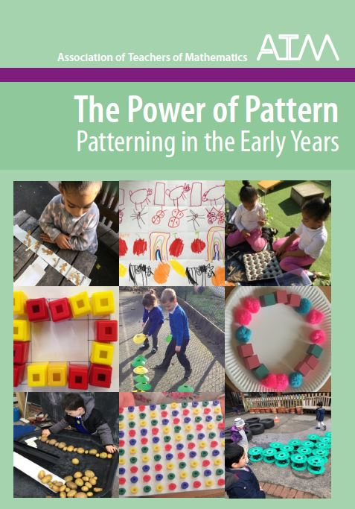

***The Power of Pattern - Patterning in the Early Years***

Borthwick. A, Gifford. S, Thouless, H

2021