Basic modelling clay recipe

SHOPPING LIST

Cornflour

Bicarbonate of soda

Food colouring

# Ingredients

1 cup of cornflour

1 ½ cup of water

2 cups of bicarbonate of soda

Food colouring if needed

# Directions

1. Support the children to measure out the ingredients, talk about halves, thirds and quarters and full cups and support children to use this language whilst working out the sizes
2. Ask the children to mix all ingredients together in a saucepan until it looks like a runny cream
3. Cook over medium heat, stirring continuously ensuring you scrape the mixture off the side of the pan as you go
4. The mixture will start to bubble then turn quickly into a consistency of mashed potato
5. Turn the mixture onto baking paper and cover with a damp towel and allow to cool
6. 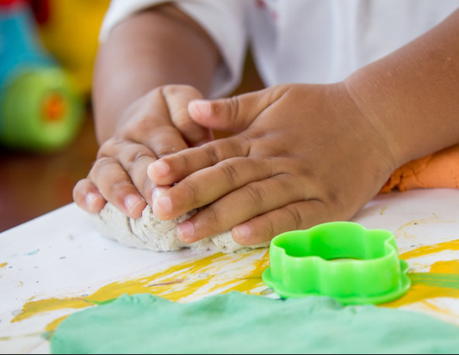Once cooled you can kneed it and make models. It should last up to a month in a zip lock bag
7. Once you have made your models cook in a warm oven (approx. 160) for an hour until they are fully dry, then you can paint