**Shape language**

**Sue Gifford (2022)**

We want children to learn to recognise shapes by their characteristics or properties, not just by recognising one example (or by its colour in a set). So we focus attention on these to begin, rather over - emphasising shape names.

**These are the main characteristics:**

**Curvedness or straightness:** *curved, round,* or *straight* (*flat* for 3D solid shapes)

Informal: *bendy, bumpy, wavy, wiggly, looping, zigzag*

**Angle size:** smaller or larger than a right angle (*acute* or *obtuse*)

Informal: *pointy, sharp corner*, *square corner, sloping*

**Numbers:** of*sides, corners or vertices* (*faces*, *flat sides*, and *edges* for 3D solid shapes)

**Side length:** *equal, longer, shorter (*and later *parallel)*

**Shape names** should be associated with properties:

***Circle:*** a continuous perfectly round shape

***Sphere:*** a 3D shape- informal: *ball*

***Rectangle:*** a 2D shape with four right angles

***Square:*** a very special kind of rectangle with equal length sides

***Cuboid:*** a 3D solid shape with 6 rectangular sides - informal: *box*

***Triangle:*** a 2D shape with 3 sides

***Pyramid:*** a 3D shape with mostly triangular faces

***Triangular prism:*** a 3D shape with triangular end faces- *Toblerone*!

We can focus attention on shape properties by using a range of appropriate vocabulary, talking about *circuits,* or *steeply sloping* paths, buildings with *tall sides* and maybe *pointy corners*.

It helps to compare shapes with objects, such as a *ball, box* or *cone,* *egg-shaped, roof-shaped, fan-shaped*, *looping,* *wavy,* and *scalloped*.

Particular contexts have special vocabulary, such as *toothy*, *arrow*- or *hand-shaped* when describing leaves.

Sometimes with children we develop shared terms with specific meanings such as *holes*, *bumps* and *sticky-out bits* to describe jigsaw pieces.

The main aim is to develop more specific terms to identify a wider range of shape characteristics, so it helps to provide a wide range of shapes and talk about shapes in a range of contexts.

*The images and information below are to support staff confidence with shape language. This is not an exhaustive list.*

**Sphere**

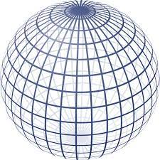

***A 3D shape***

***Informal: ball***

***A continuous perfectly round shape***

**Circle**

***A continuous perfectly round shape***

**Square**

***A very special kind of rectangle with equal length sides***

**Rectangle**

***A 2D shape with four right angles***

**Triangle**

***A 2D shape with 3 sides***

**Cuboid**

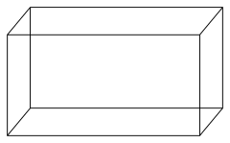

***A 3D solid shape with 6 rectangular sides Informal: box***

**Triangular prism**

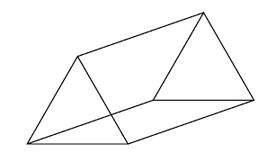

***A 3D shape with triangular end faces***

***Informal: Toblerone!***

**Pyramid**

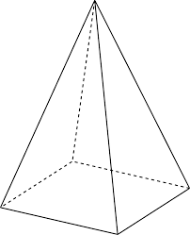

***A 3D shape with mostly triangular faces***

**Curved**

**Straight**

**Flat**

**Round**

**Bendy**

**Bumpy**

**Wiggly**

**Wavy**

**Zigzag**

**Looping**

**Pointy**

**Sharp corner**

**Sloping**

**Square corner**

**Corners**

**Sides**

**Vertices**

**Flat sides**

**Faces**

**Edges**

**Equal**

**Longer**

**Shorter**

**Scalloped**

**Egg-shaped**

**Roof-shaped**

**Fan-shaped**

**Heart-shaped**

**Looping**

**Holes**

**Bumps**